Georgia Sugisandhea_535230080_Kelas C

1. Ketergantungan fungsional

* Partial Dependency
  + PetsID, DoctorID -> register, checked, Diagnose
  + PetsID -> petsName, petsDOB, OwnerID, ownerName
  + DoctorID -> DoctorfName
* Transitive Dependency
* PetsID, DoctorID -> register, checked, Diagnose
* PetsID -> petsName, petsDOB, OwnerID
* OwnerID -> ownerName
* DoctorID -> DoctorName

1. Normalisasi

* 2NF

check_up table

|  |  |  |  |  |
| --- | --- | --- | --- | --- |
| petsID | DoctorID | register | checked | Diagnose |
| Pe102 | ST19 | 2/10/19 | 6/18/18 | Sick |
| Pe103 | ST31 | 5/10/18 | 9/21/28 | Healthy |
| Pe103 | ST32 | 5/10/18 | 6/18/18 | Check |
| Pe105 | ST19 | 8/8/17 | 6/18/18 | Sick |
| Pe105 | ST32 | 8/8/17 | 8/8/19 | Check |
| Pe104 | ST31 | 9/21/18 | 10/10/17 | Sick |
| Pe107 | ST31 | 6/18/19 | 9/21/18 | Healthy |
| Pe101 | ST21 | 6/18/19 | 6/18/19 | Healthy |
| Pe101 | ST19 | 6/18/19 | 6/18/19 | Sick |

pets table

|  |  |  |  |  |
| --- | --- | --- | --- | --- |
| PetsID | petsName | petsDOB | OwnerID | ownerName |
| Pe102 | Blacki | 10/10/15 | OW007 | Jimm Bob |
| Pe103 | Micki | 10/10/15 | OW002 | Misson |
| Pe105 | Binggo La | 11/15/10 | OW005 | Kagnee |
| Pe104 | Lixmi Joo | 2/2/12 | OW006 | Jael Gray |
| Pe107 | Jorg | 10/3/11 | OW001 | Alez Lim |
| Pe101 | Binggo | 5/12/15 | OW001 | Alez Lim |

doctor table

|  |  |
| --- | --- |
| DoctorID | DoctorfName |
| ST19 | Noermad Zo |
| ST31 | Thomas Shaw |
| ST32 | Tina Murphy |
| ST21 | Zoe Carol |

* 3NF

check_up table

|  |  |  |  |  |
| --- | --- | --- | --- | --- |
| petsID (fk) | DoctorID (fk) | register | checked | Diagnose |
| Pe102 | ST19 | 2/10/19 | 6/18/18 | Sick |
| Pe103 | ST31 | 5/10/18 | 9/21/28 | Healthy |
| Pe103 | ST32 | 5/10/18 | 6/18/18 | Check |
| Pe105 | ST19 | 8/8/17 | 6/18/18 | Sick |
| Pe105 | ST32 | 8/8/17 | 8/8/19 | Check |
| Pe104 | ST31 | 9/21/18 | 10/10/17 | Sick |
| Pe107 | ST31 | 6/18/19 | 9/21/18 | Healthy |
| Pe101 | ST21 | 6/18/19 | 6/18/19 | Healthy |
| Pe101 | ST19 | 6/18/19 | 6/18/19 | Sick |

pets table

|  |  |  |  |
| --- | --- | --- | --- |
| petsID (pk) | petsName | petsDOB | OwnerID (fk) |
| Pe102 | Blacki | 10/10/15 | OW007 |
| Pe103 | Micki | 10/10/15 | OW002 |
| Pe105 | Binggo La | 11/15/10 | OW005 |
| Pe104 | Lixmi Joo | 2/2/12 | OW006 |
| Pe107 | Jorg | 10/3/11 | OW001 |
| Pe101 | Binggo | 5/12/15 | OW001 |

owner table

|  |  |
| --- | --- |
| OwnerID (pk) | ownerName |
| OW007 | Jimm Bob |
| OW002 | Misson |
| OW005 | Kagnee |
| OW006 | Jael Gray |
| OW001 | Alez Lim |

doctor table

|  |  |
| --- | --- |
| DoctorID (pk) | DoctorfName |
| ST19 | Noermad Zo |
| ST31 | Thomas Shaw |
| ST32 | Tina Murphy |
| ST21 | Zoe Carol |

1. Primary Key dan Foreign Key

* check_up table :

primary key = petsID, DoctorID, checked (composite) (asumsi bahwa peliharaan yang sama bisa datang berulang kali ke dokter yang sama, sehingga composite petsID dan DoctorID tidak cukup)

foreign key = petsID dari table pets, DoctorID dari table doctor

* pets table:

primary key = petsID

foreign key = OwnerID dari table owner

* owner table:

primary key = OwnerID

* doctor table:

primary key = DoctorID

1. model ER

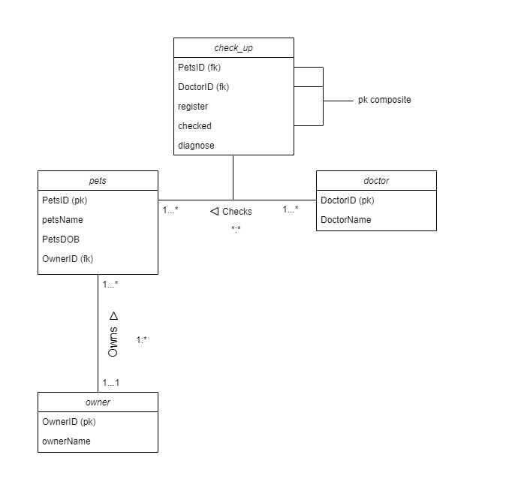

Asumsi many to many relationship antara pets dan doctor karena pets yang sama bisa datang berulang kali ke doctor yang sama.